Arcturus Steel – Technical Workshop
Minutes, 9 July 2026, Eastholm rolling mill
Sofie Lindqvist · 10 July 2026
Weyland: Sofie Lindqvist, Isabel Ferreira, Mei Tanaka
Arcturus: Energy manager, furnace engineer, plant HSE lead

1. Site tour
Tour of the reheating furnace and gas train. The furnace has three zones; hydrogen co-firing is planned first in the soaking zone where burner access is easiest.
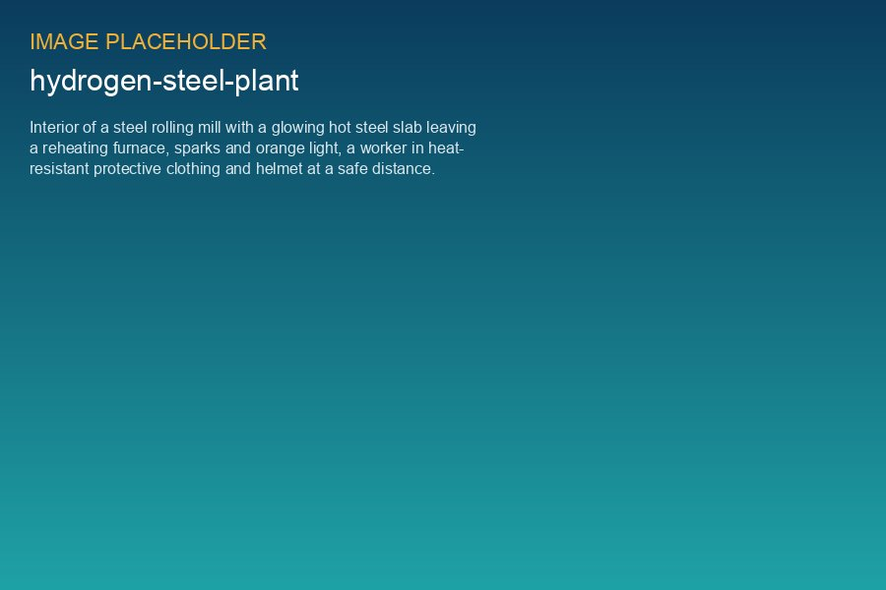
Reheating furnace at the Arcturus rolling mill

2. Demand profile
- Trial year ≈ 330 t, full operation ≈ 490 t/a (see demand profile workbook).
- Peak flow 95 kg/h; pressure required at mill fence 8 bar.
- Three-week maintenance shutdown in July every year.

3. Interfaces
- Pipeline: Weyland to the mill fence, Arcturus inside the premises.
- Metering at the fence, custody transfer to Arcturus.
- Emergency shutdown signals exchanged both ways (hard-wired).

4. Actions
Action | Owner | Due
Send updated demand profile | Arcturus energy manager | 2026-07-17
Pipeline routing options along port corridor | Isabel Ferreira | 2026-07-31
Burner supplier statement on NOx at 30 % H2 | Arcturus furnace engineer | 2026-08-14

